Abstract Title. Use this format for abstracts for the CATSA 2024 Conference – simply select each section and replace with your own text.
First Author,ª Second Author^{b} and Third Authorª
ª Department of Chemistry, West Coast University, Corner Post Office, Paternoster, 7381, South Africa, E-mail: first@wcu.ac.za. ^{b} School of Alternative Sciences, Just off Main Street, Pofadder, 8890, South Africa.
Keywords: structures, perspectives, reactions, metal, catalyst.

The abstracts for the CATSA 2024 Conference should be submitted in the format of this document. They will thus be an A4 page with 1.8 and 2.5 cm margins top and bottom, respectively, and side margins of 2.5cm. The preferred font is Times New Roman, font size 11 and single-spaced. The abstract including the title, author affiliations, and any references should not exceed one page: if they do they will not be accepted and will be returned to the author(s) for further editing and resubmission.

Fonts and Formatting: Please retain the fonts and paragraph settings in this template.
Do not edit or add anything to the Header/Footer fields in the document.
Title: Two lines for the title are strongly recommended.
Authors: The presenting author’s name must be underlined and his/her e-mail address included after the relevant address. Please use superscript letters to indicate author affiliations as shown in the format above. Do not append degrees, professional designations, etc., to names.
Affiliations: Should be listed consecutively.
Table, Structure and/or Scheme: A figure, table and/or scheme are acceptable but have to fit within the one-page limit (Table 1, Fig. 1, Scheme 1). A ChemDraw, ISISDraw, ChemWindows or ChemSketch figure that summarizes the compound(s) studied or depicts the work undertaken must be copied and pasted in the frame as indicated in this template. An ORTEP or other high-quality diagram is also acceptable. A high-quality (min 300 dpi, max1200 dpi) JPEG, TIFF or bitmap image (no bigger than 300 KB, i.e., use compression on export in Corel Draw, for example) is strongly recommended. Furthermore, please ensure the font sizes used within figures are legible in the abstract.

Other: Equations should use Equation style, and should be tab centred with the number on the right.

Table 1: Summary of font sizes to use. Figure 1: Example of a figure.
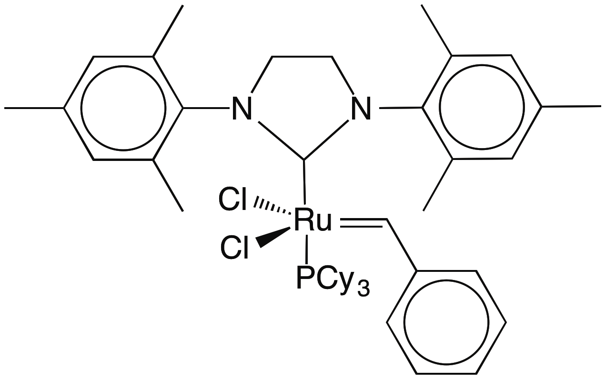
Section | Size | Style
Title | 14pt | Bold
Authors | 12pt | Italics
Affiliation | 9pt | Italics
Text | 11pt | Normal
References | 8pt | Normal

The first line of each paragraph should not be indented. References (if any) should be indicated by numbers in square brackets [1], [2]…etc. in the text and be given at the end of the abstract, below the footnote line.[1]

Please submit the abstract as a Word 2007/2010/2013 etc. document for Windows, or Word 2004/2008/2011 document for Mac. Only electronic submissions will be accepted.

[1] First, A; Second, B and Third, C. Organometallics, 2006, 25, 123-456.

